**Mail Id:** [**arjya.garai@gmail.com**](mailto:arjya.garai@gmail.com)

**VARIABLES – Exercise**

1. Declare a variable without breaking any of the rules
2. Declare this variable “print = 30”. Which rule does it break ?
3. Make changes to these variables so that they no longer break the rules to

define a variable

1. phone$number = 12345

2. 123Name = “CodeHub”

**NUMBERS - Exercise**

1. Write a program to assign the value 30 to an integer variable
2. Write a program to declare a floating value 55.77 and convert it to integer and print the result

**OPERATORS - Exercise**

1. Write a program to add two numbers
2. Solve this equation manually.

2 + 3 * 4

Now write a program to solve this.

Did you get the same answer?

1. Use a logical operator in between two comparison operators and return the value as true

**STRINGS – Exercise**

1. Write a program to create a string “Python programming is easy”
2. Now slice the first string and store “easy” in the second string
3. Replace “easy” in the second string with “ and powerful” and concatenate both

the strings

1. **Instructions:**

Open below file, there are errors in all the lines of code. Fix the code so that it runs without errors and produce below output.



Example Output:

When you run your program, it should print the following:

CodeHub - String Exercise

String Concatenation is done with the "+" sign.

e.g. print("Hello " + "world")

New lines can be created with a backslash and n.

**LIST - Exercise**

1. Write a program to create a list of 5 elements
2. Update the value at 3rd element of the list
3. Create another list of 3 elements. Now create a final result as a concatenation of the first two lists
4. Suppose you are an interviewer. Candidate has filled his skills like: Java, C, C++

**Action:** Declare a list with items- Java, C, C++

Now during interview you asked, What else he knows apart from he mentioned his in resume.

He told he knows Python, HTML

**Action:** Add these two also in the list.

But during interview he was not able give any ans from Java.

**Action:** Remove java from his skill list.

**Action:** Print the final skill list.

1. Suppose you are a private tutor. Your student is studying in Class 7 and his parents are busy. So you have to visit his school and collect all the subjects as a list.

You discuss with one Guardian at the school gate who can able to tell you 3 subjects (Math, Science, and History), Another guardian can able to tell you another 4 subjects (Take any 4 subjects of ur choice).Now take input from users as subject name one by one and keep adding in the list.

Finally, print the List.

Hints:

sujectList = [] ---------- Create a blank list

print("Gurd 1 is giving input") ---------- Ask user to provide input

subj1 = input() ---------- Store Subject 1 in one variable

######Now add in the list#########

subj2 = input() ---------- Similarly Subject2

###### Again add in the list#########

subj3 = input() ---------- Similarly Subject3

**DICTIONARY – Exercise**

1. Write a program to create a dictionary with 5 key-value pairs
2. Update the value of a key
3. Copy this dictionary to another dictionary and clear the first dictionary
4. Write a Python program to add a key to a dictionary.

Sample Dictionary : {0: 10, 1: 20}

Expected Result : {0: 10, 1: 20, 2: 30}

1. Access the value of key math

sampleDict = {

"class":{

"student":{

"name":"Ayush",

"marks":{

"physics":70,

"math":80

}

}

}

}

1. Given a Python dictionary, Change Ayush's salary to 8500

sampleDict = {

'emp1': {'name': 'Ayush', salary': 7500},

'emp2': {'name': 'Nikhil', 'salary': 8000},

'emp3': {'name': 'John', 'salary': 6500}

}

**CONDITIONALS - Exercise**

1. Write a program to check if a number is less than 10
2. Write a program to check if a given number is odd or even
3. Write a program to check if a number is divisible by both 10 as well as 50. If it is divisible by 30 as well, print “This number is divisible by 10, 50 and 30”. If not, print “This number divisible by 10 and 50 but not 30”
4. **Pizza Order**

Congratulations, you've got a job at Python Pizza. Your first job is to build an automatic pizza order program. Based on a user's order, work out their final bill.

Small Pizza: 100

Medium Pizza: 200

Large Pizza: 300

Pepperoni for Small Pizza: 50

Pepperoni for Medium or Large Pizza: 100  
Extra cheese for any size pizza: 20

# Example Input

size = "L"

add_pepperoni = "Y"

extra_cheese = "N"

# Example Output

Your final bill is: 400

# Hint

Think about what you've learnt about multiple if statements and see if you can reduce the number of lines of code while having the same functionality.

1. **Treasure Island**

Cliparts: <https://ascii.co.uk/art>

**Check the FlowChart from below Pdf file:**



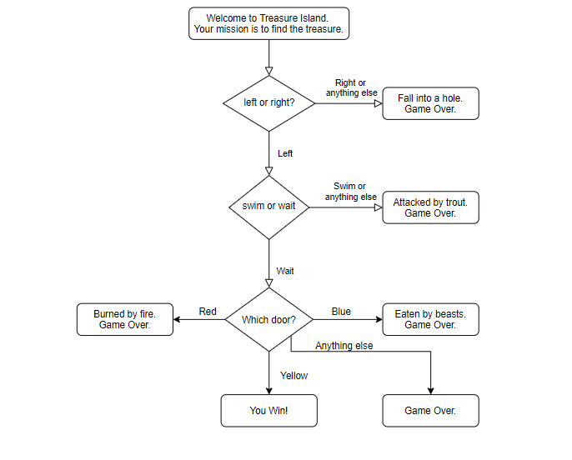

**Open below file:**

